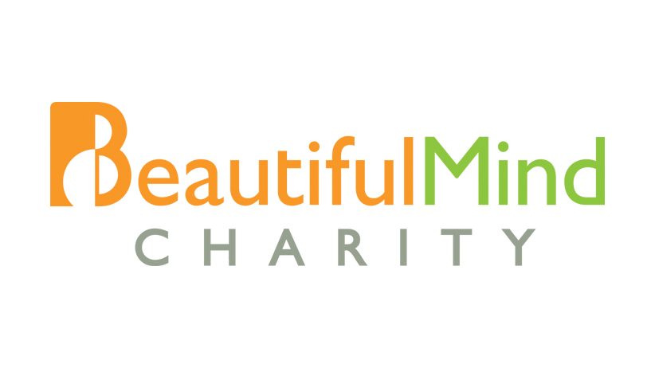
Please attach recent photo

VOLUNTEER APPLICATION FORM
(Beautiful Mind Music Academy)

1. MUSICAL INSTRUMENT _________________________________

2. MY PERSONAL PARTICULARS

Name : __________________________________ NRIC / FIN : ____________________ Birth date : _______________________________ Marital Status : ___________________
Languages / dialects spoken : _____________________________________________________
Citizenship : ______________________________ Occupation : _____________________
Home Address : ________________________________________________________________
Postal Code : ______________________________ Email Address : ___________________
Contact No (Home / Mobile) : ____________________________________________________

3. MY QUALIFICATION / EDUCATION IN MUSIC

Please fill in your professional music qualifications and training where applicable:

 | Period | Instrument | Qualification
1
2
3

Other relevant music training obtained:

_______________________________________________________________________________

_______________________________________________________________________________

4. MY REFERENCES

Please provide 2 references who can help us to determine your suitability to be a BMMA volunteer. References preferably to be outside of immediate family members and relatives.

 | Name | Relationship to you  (e.g. Friend, ex-employer, Employer, ex-colleague) | Years Known | Contact
1
2

5. OTHER VOLUNTEER HELP

Please indicate if you are able to volunteer with the following other than teaching music:

- Volunteer driver [ Yes / No ]
(Drive students with disabilities from their home to music studio and back)

- Chaperone [ Yes / No ]
(Accompany students with disabilities from their home to music studio and back)

- Administration / Event [ Yes / No ]
(Help with administration and event)

- Editorial / Website / Design [ Yes / No ]
(Writing and editing newsletter, design website/newsletter/brochure)

- Any others, please suggest:

____________________________________________________________________________

____________________________________________________________________________

6. DECLARATION

Have you ever been convicted of a criminal charge? [Yes / No]
If you have indicated “Yes”, please provide details below
_______________________________________________________________________________

_______________________________________________________________________________

The information provided in this application is true and accurate to the best of my knowledge. I understand that any willful act on my part in withholding information or making false statements in the application form is in itself, sufficient grounds for dismissal from the Volunteer Programme.

____________________________________ _______________________________
Name NRIC / FIN

____________________________________ ________________________________ Signature Date

